FortuneONE.org CreatorKeith.com
PeaceSummit2020@gmail.com
+1 770 377-2106 Atl, GA. Asheville NC USA
UNIocracy.ORG Evote.one FOIA.one Unifier forever.
ReInvestALL.com GODs crime free New World
Command we host Press Conferences NOW!
SolutionMilitary.com TurnOffLights.com
WorldSchoolFund.org beSmartBeRICH.com
DuncanCLAIM.org !!! +$500 Million USD

Everyone CROSS promote mass publicity REINVESTALL.com and world changing original 100% direct eDemocracy voting of EVOTE.ONE. YOU WILL BE PAID to help eliminate ALL those who cause world mass poverty and all Wars USING these simple ancient GODs methods of 5steps.life generator. CreatorKeith.com is YodaKeith.org and original BidOnKeith.com Duncan 770-377-2106 CALL us ONLY if you are not a CYBER SCAMMER Con-artists who YOU now eliminate by use of SolutionLawENFORCEment.com FOIA.ONE

eVOTE.ONE is total economic replacement direct real time eDemocracy voting decision system. These simple GODs four complete perfected replacement Commandment Constitutional Universal laws of SolutionManifesto.com change the course of our human legacy history forever:

1. We vote on Who is the new NEXT Project Manager using FOIA.ONE as worlds last open public shared database of everything.
2. We vote OUT any person who refuses to complete #3 projects. KeithsRulesOfOrder.com multilevel assigned reported tracked proxy system ensures all decisions are made using 5Steps.LIFE agreements that benefit everyone while null and voiding all previous laws and related legally binding agreements.
3. We vote on the NEXT best project by majority deciding on our NEXT best local issue, problem, project, and petition using our assets, times, and tax money. PeaceSummit2020.com occurs monthly.
4. We vote UP, DOWN, or same the cash paid to each leader. This includes WE control all decisions and pay of all our Corporate Executives worldwide. We Null and Void all Stock Options, Campaign Contributors, all special interest group lobbyists, and destroy all legal and criminal embezzlement of our assets and funds.
Four more comprehensive perfected retro-active requirement replacement laws are showcased here.
Worst crimes of WMD of heresy heresay are eliminated by ACTION of WE GODs people SolutionLawEnforcement.com InterPOLICE.live SolutionJudge.com Of Gods DOSJ.org UNIocracy.org forever. Include fast path rapid deployment of all +150 World save changing solutions at CreatorKeith.com

FortuneONE.org CreatorKeith.com World UNIOCRACY.ORG ANSWERS FOR HUMANITY

### WORLD PRESS re-RELEASE Monthly held Town Hall Forum Conclaves use:

PeaceSummit2023.com Each Sunday Host ProphetKeith.com +1 770-377-2106

All world Presidents + top Elite Corp Executives Commanded to attend Town Forums.
1. We solve all base world problems 5Steps.life as Public Servants of We Gods People.
2. FOIA.one IID Who is Who. Share all evidence of who are top violators to purge.
3. Assign SolutionMilitary.com to find terrorists Open Public Investigations.
4. Agree to redistribute crime wealth to 3rd world nations in greatest need using Evote.One CreatorKeith.com 1% seized and crowdfunds of +7.9B Gods People.
5. Agree to transfer millions of our young adults to places of greatest needs with WorldSchoolFund.Org 100% free Foreign Exchange Student Keith's Program.
6. Agree to remove all by-laws and regulations that prohibit the immediate deploy of ProfitShareHolders.com from being our new world free trade total barter society.
7. Agree to eliminate all corporate corrupt criminal violators of human rights individuals using Will of Free Citizens use of Gods SolutionJudge.com by EVOTE.ONE.
8. Agree to universal FOIA.one IID and eliminate purge DOJ DOD Corporate Executives who violate laws SolutionLawEnforcement.com + SolutionManifesto.com
9. Protect the lives + Assets of SaintKeith.com + those of highest IQ merit.
All Presidential, Leaders, Corporate Executives Work for GODS people. Reset from Sept 2011. WhereIsRobertRose.com and DUNCANClaim.org
Each of these are CLIENT3635.wix.com/* world self saving solutions.
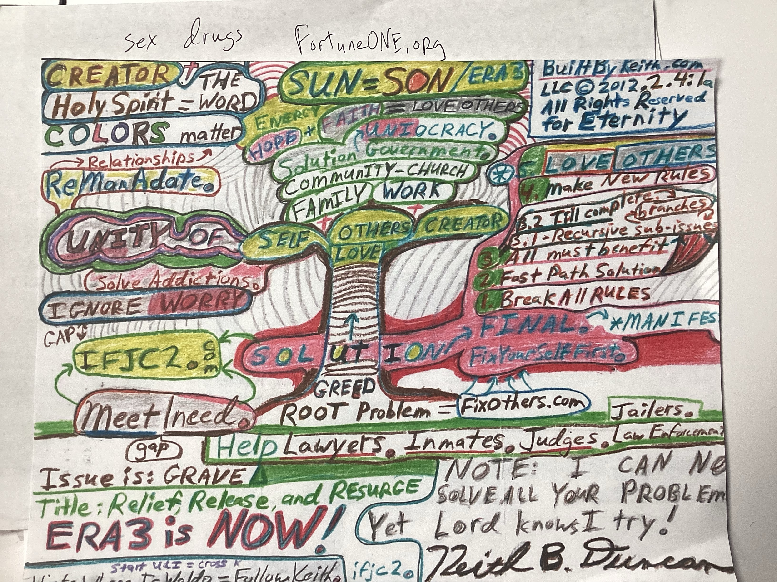
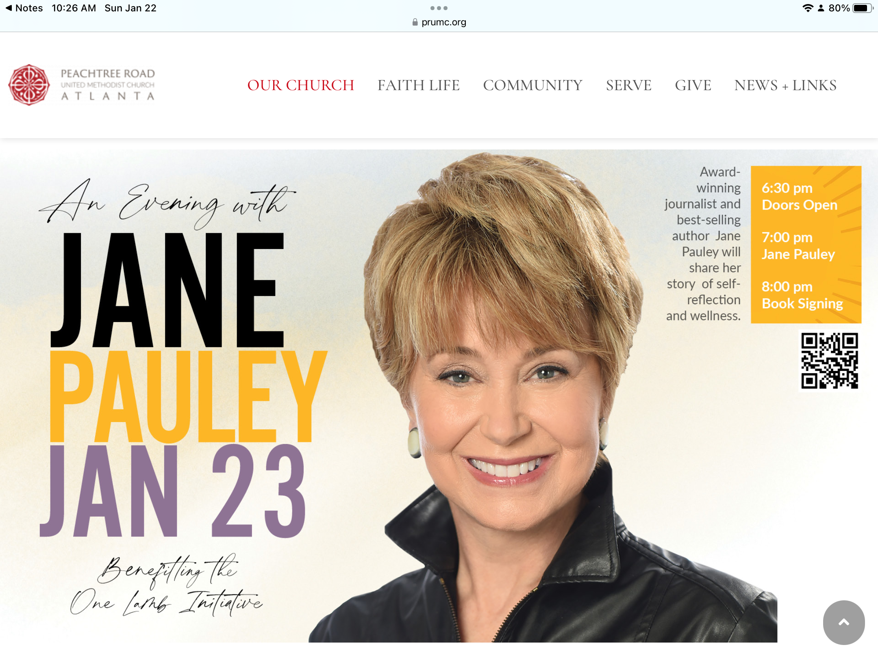
### Jan 23, 2023 Total of 144 GODs world reform new world systems (ordered).
5Steps.LIFE. Basic GODs generator procreates all method solutions and life. File: PeaceSUMMIT2023-EVOTEone-FortuneONEorg-NGO-2023Jan23.pdf

